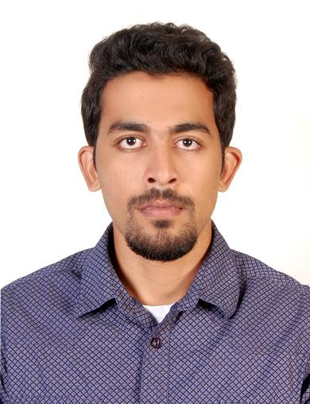
CURICULLAM VITAE

Vishnu.S.Nair
Contact No :+91 8891640034
+918921241742
Email id : visnair90@gmail.com

OBJECTIVE
To work in an organization to increase my skills and knowledge, at the same time being flexible and resourceful to the organization and working hard to achieve the goal of the organization
EDUCATIONAL QUALIFICATION
Diploma in mechanical engineering ( first class)
(Chaudrycharansingh university 2009-2012)

Higher secondary education (+2)
( Govt model higher secondary education 2007)
Secondary school leaving certificate (SSLC)
(Govt model higher secondary school 2005)

WORK EXPERINCES:
- I working in “DIGITALS INDIA SECURITY PRODUCTS PVT LTD” as Technicalengineer (MARCH 2016 TO 31 MAY 2018 )
JOB ROLE
- Installation / service of cctv,fires alarm system & security alarm system.
- Troubleshooting and repair of various systems.
- Able to read and comprehend blueprints.
- Knowledgeable of power tools and most hand tools.
- Support and troubleshooting servers, computers, wireless, switches, printers mobile devices, etc.
- Software installation and application support.
- Provide support to end users locally and remotely. Cable installation, CCTV cameras installation, DVR configuration, access and support

- I had worked in” LGB FORGING INDIA PVT LTD” as Production supervisor ( through contract with Amritha engineering pvt ltd ,Mumbai)
(MARCH 2014 TO 31 DECEMBER 2015)
JOB ROLE
- planning& Organizing staff shifts rotate and tasks
- Reporting plant or machinery breakdown to maintaince technician
- Organizing external contact like cleaning or supplies.
- Stock control, Motivating your team.
- producing management report on performance
- Monitoring quality control, Updating paperwork
- Identifying and Organizing training needs

- I had worked in “SYNTHITE INDUSTRIES PVT LTD” as Production operator
( 15 JUNE 2012 TO 10 JANUARY 2014)
JOB ROLE
- Setup the production equipment and supplies before executing the job role
- operate equipment safety and effectively for production processing
- Ensure that equipment are maintained in good and safe working condition
- perform regular equipment maintain to ensure production capacity and quality
- Provide assistance to junior operator in their assigned responsibility
- Repair and clean the equipment when needed
- Work under the guidance of supervisor to perform and complete the assigned duties
- Evaluate equipment performance and recommend improvement.
- Follow safety procedures and company policies for equipment operations
- Recommend process improvement to enhance operational efficiency and safety
- Identify and report unsafe operations to supervisor immediately
- Maintain the work area clean safe and organized.

- I have worked in “JSW STEEL PLANT “ as NDT Technician
( 1 APRIL 2012 TO 31 MAY 2012)
COURSES COMPLETED:
- NDT ( Non destructive testing) level 2 certification
- Ultra sonic immersion technique(RT)
- Radio graphic testing (RT)
- Magnetic particle testing (MPT
- Liquid penetrant testing (PT)

Project;
“ Automatic distance measurement and breaking system using ultrasonic”
Seminar;
“Metal detector”

COMPUTER SKILLS:
Diploma in computer application (DCA)
Introduction to Computer, windows, MS word, excel, powerpoint
Autocadd& Pro E (Mechanical CADD)

PERSONAL INFORMATION:
Name : VISHNU.S.NAIR
Address : (H.NO)L.I.G-41, SHASTHRI NAGAR COLONY
ERANHIPALAM, CALICUT.673006
Telephone No : +918891640034
E-Mail Address : visnair90@gmail.com
Date of Birth : 08/05/1989
Nationality : INDIAN
Passport details : KO 515629
(27/10/2011 to 26/10/2021)
SELF EVALUATION
Hardworking and sincere. My biggest sense of achievement lies in my gaining maturity and independence to exercise power of thinking responsibility of taking decision.
DECLARATION
I assure that the above mentioned informations are true to the best of my knowledge and belief and I have supporting documents to prove them.

Place : Calicut Vishnu.s.nair
Date :

